THE

LESSER

KINGDOM

By
FREDA LONNEN NORTON

CONTENTS

CHAPTER PAGE

1 OPAL 5
2 BOBBIE 12
3 SIXPENCE 18
4 BUNTY 23
5 PADDY 31
6 LIZZIE’S ‘LEE’EL ‘OGS’ 35
7 ROBIN 40
8 CHANG 45
9 JUNO 50
10 LITTLEJOHN 54
11 THE GOAT THAT CRIED 57
12 LOST AND FOUND 61
13 WINGS 67
14 ODDS AND BODS 71
ADDENDUM 81

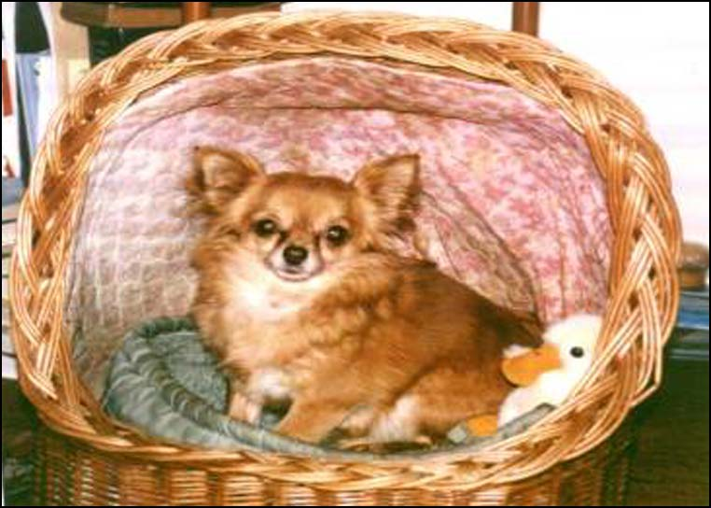

MY PRECIOUS OPAL

The Lesser Kingdom
- by Freda Lonnen-Norton

Chapter One

OPAL

Since writing my humble book about the Little Angels who have helped me so much all the years of my life, and being requested by a few friends to endeavour to produce one about some of the many animals, who have also given me so much love and light on my life journey, I am trying to put pen to paper again, and name my effort, dedicated mainly to one little fluffy Chihuahua named OPAL, a special jewel in their crown. So here I am, at 4am. on a rather cold, damp November morning, in my dressing gown, a cup of coffee beside me, literally putting biro to a scrap of paper, as my typewriter has again gone kaput! But why, you say, at 4o/clock in the morning? Go to bed woman!
Let me explain . . . . .
A few weeks before Christmas 2005 my family persuaded me to write the book I had threatened to inflict upon them for years, about my special ‘Little Angels’, not big important angels, with wings and haloes and long flowing robes, but those I felt were close to me – parents and grandparents, siblings, children and friends – all of course on their own travels of progression in a greater world of experience, not by my side all the time, or trying to dictate my life and cramp my own promised freewill, but to endeavour sometimes to impress a little advice if I really felt at a crossroads, without a clue which way to turn.
For myself, if I do get in that position, I just stand still and wait, after asking for a little help, have always been sort of pushed in the right direction, not always, I haste to say, the direction I WANT, but the way I NEED to keep me on a right path to learn the lessons we came into this life to learn.
I saved a long time to pay a very special printer to produce my books, and I risked having 500 published to save cost – the more I bought, the less the price for printing. I gave away about 250 as Christmas presents and to family and friends who would accept them, and also young folk (or old) new to our wonderful philosophy, hoping reading one of those simple books might help their lives as much as my little knowledge has helped mine. The rest of the books were sold in some of the churches I still serve in Cornwall, repaying some of what the printing cost me and, in most cases, including a donation to their church, and for this I was very grateful.
In our Spiritualist movement there are a number of people who, like myself, are often aware of the human ‘Little Angels’, and also the special creatures God created, often referred to as THE LESSER KINGDOM, and many have asked if I would write of my experiences with some of those who have given me personally such devotion and love in their own short sojourn on Earth. That is why, at 4am. on this wee bit chilly morning, after being more or less ordered out of a warm bed by thoughts and memories of that precious little golden bundle curled up, wrapped in her special rug in her basket at my feet, so fast asleep she does not move at all, because early yesterday evening her dodgy little heart, despite medication and loving care, suddenly stopped beating and as I gently, very gently and carefully took her in my arms, her eyes closed and another little friend had slipped away. I was grateful that she had spent the last four years of her life in a happy ‘retirement’ home, with a comfortable rug on the end of ‘Mum’s’ bed instead of in a puppy farm where I am sure she was well looked after, but had not the tender loving care from everyone who knew her.
Opal was not the first dog by any means, and I was warned that her life was drawing to a close because our home had been invaded for about two weeks by spirit cats and dogs, sometimes glimpsed, only occasionally really seen clearly, and I frequently almost fell over one of them, and I know she was well aware of them, and probably saw them far more clearly than I could.
Since she died all the activity has ceased, no one around at all, so I pray they are busy acclimatising her to her new environment. To any dear practical, sensible being, who has acquired this book and read this far, I know this is true. I felt certain they were waiting to greet her, because a week ago I begged my daughter to take us to our kind and helpful vet, because Opal was coughing so badly, and he had told my daughter quietly, apparently not to upset the wobbly nonagenarian who was going off to the reception to pick up more tablets and pay the rather large bill, that “The little dog is in no pain, but very, very ill, so look after them”, as if I did not know. But their care and knowledge, I realise, had given Opal a few more weeks, perhaps even months, of happy pain free life with her old Mum, so many thanks lads!
On the next St. Valentine’s Day she would have been eleven years old, and I am grateful that her Maker loaned her to me for our happy four years together. What a blessing so many of these creatures, Great and Small, are to those of us who can love and accept them, and how sorry I am for those who cannot- - - they can often teach us humans a lot!
Opal was not the first dog who ever settled down with me (that honour goes to a little Heinz 57, called Sixpence, but more about him later), but I have definitely decided she is the last – my poor old heart just cannot stand the strain. Thank God I truly believe that one day we shall all meet again. Of course, if anyone is desperate for a dog-sitter or cat-sitter or budgie-sitter or guinea-pig ditto, etc, etc within reason, I am in the telephone book under F.NORTON, and will endeavour to assist, now recalling the saying - -

Oh! I was foolish indeed to lend

In such a trusting way
My stupid heart for a dog to rend
And carry a piece away.

Alas! Kipling was right when he wrote those memorable lines. How often in my life it has happened to me. I vowed that, knocking up to ninety years I would never have another pet of any kind when my precious Bobbie died, but of course it was out of my hands altogether, I did not know that another little Chihuahua called Opal, was waiting around the corner for me.
My first sight of Opal, tucked back to front under her owner’s arm, was a golden tail wagging when she was carried indoors. We all sat down, and the bundle was dumped on my lap! The breeder told me to ‘try’ her a few days, as she might miss the other dogs and her little ‘cardboard box’ she slept in. She would leave her a while to settle, and I must let her know if I wanted to keep her. Opal did take a time to settle – about five, or maybe two minutes. Off went her former boss, and two wide brown eyes looked at me. She lifted her head and licked me under the chin and I must have tasted all right – Opal had come home and found, I think, the Mum to spend the rest of her life with. She sure didn’t take long to settle, neither did I, to realise how fortunate I was.

OPAL

An optimistic Opal is curled upon my bed
Half hidden by the nylon eiderdown
And all that’s visible, a golden ear and half a head
And one big pleading eye of liquid brown.

Little optimistic animal, as hopeful as can be,
Who’s thinking I don’t even know she’s there,
And wondering if I’ll get in bed and never even see
A small Chihuahua curled up anywhere.

Such an optimistic Opal! It would be so unkind
To shut her outside in the garden shed,
I’ll stroke her very gently and tell her I don’t mind
And we can warm ourselves all night in bed.

Chapter Two

BOBBIE

Why I bark at the POSTMAN

Well, everyone knows I’m a Guard-dog ,
Though they may think that I’m a bit small,
But I have to protect my old Missus,
No one else ever tries to at all!
You know, nearly every morning
This great big bloke tries to sneak in,
And it is such a boost to my ego
When he cringes away at my din.
So I bark at him my most loudest
In my efforts to drive him away,
But somehow he won’t heed my warnings –
He sneaks back again the next day.
Missus lifted me up to be friendly,
And he even risked patting my head,
But I jolly-well growled like a tiger
To warn him I’m someone to dread.
I don’t know how Missus can stand him
Chucking all his junk on our mat,
But I won’t let him over the doorstep –
I’m the BOSS in this kennel, that’s flat!
Good job she’s got me to protect her;
I’m a friendly dog up to a point,
But I won’t let that flipping great Postman
Put MY little nose out of joint!
‘BOBBIE NORTON’

Bobbie was an entirely different kettle of fish. He certainly did not settle in minutes! It took hours, days, weeks! The reason I bought him was that some time previously my dear old friend Millie died, and I had promised to look after her little dog Chi, who looked on me as a second Mum, because I had known her all her life, and actually spent six months with Millie before she passed away. Chi lived with me for two or three years, until she was fifteen, a good age really for a Chihuahua. Of course, I missed her and looked out for another little companion, and someone told me about the small dogs (Chih’, Pom’s, etc.) puppy farm, who sold off bitches past a breeding life, so I contacted her. She had a young dog she had bought a year before to use as a second stud dog, but the stupid creature’s mother had apparently never explained to him about the birds and bees (the facts of life), and he obviously had no idea what was expected of him in exchange for his food and lodging. Also, the older and well-established stud dog hated him on sight and almost appeared to have murderous intentions towards him! I was not keen on a dog. With one exception I had always had bitches, but I felt I should see him, because I was probably meant to have him, so off I went! He was long-haired, black and white with a little decorative tan, and he lived with me for seven years, suddenly dying of an unexpected heart attack, and I think I grieved more over him than any other pet of the dozens who have been sent into my life!
When I brought him home he seemed terrified in the car, and indoors he fled and hid in a corner behind an armchair. He was entirely non-aggressive, just frightened of me. Who he thought I was I do not know! I had great difficulty to get him to eat. I took him on a lead into the garden to wee, afraid he would get out somewhere. This went on for about two weeks! Suddenly, one evening just before bedtime, I was sitting reading, and he crept out of his hidey-hole, sat in front of me and put a paw on my knee. I pushed my book behind me, spoke quietly to him then gently lifted him up on my lap where he seemed to give a big sigh and settled down for over an hour – I had been accepted! We went to bed late that night and he seemed happy and warm on my bed until next morning he bounded, fearless, outside to water the garden, then, tail wagging, followed his first real Mum around as if he would not let me out of his sight! What a treasure he was.
After his first fear of me, sticks, fireworks and men with black hair, he was one of the friendliest dogs I have ever known. Like Opal, he loved going visiting, especially to my church, and, (unlike her) did not mind looking after our home when I told him I was ‘going shopping’. Opal never believed me, and sulked on rare occasions when I had to leave her for a little while (a doctor’s surgery does not welcome germ-ridden four-leggeds)! They both were terrified of fireworks and sudden loud bangs, lightning did not scare them much, but when God started banging around up there driving his chariot, with the wheels making sparks, which this white-lying mother used to tell my children, to explain all the noise, was not quite as frightening as fireworks to little dogs.
I do remember, years ago, two very small girls in bed during a thunderstorm, not too upset, with me sitting on the bed reading them a story, when suddenly down came a terrific BANG! A thunderbolt not awfully far away, and two little heads dived under the bedclothes and a disturbed little voice said, “Oh! God’s falled out of His Chariot! And I said, calmly “I don’t expect He’s hurt Himself”, so up they came to hear the rest of the story! I hope the Angel Gabriel forgave me!
Fortunately I am permitted to take a small dog to Church, especially at firework time or if there is thunder around, and Bobbie was also welcomed during these times at any other Church I was serving. When I was on the rostrum my God-daughter, Carol, held my little dog on her lap and afterwards it was given a ‘cup of tay’ in its own special saucer, so any non-doggy person need not worry about contamination of a ‘human’s’ saucer. I think, in our Church, the really strict anti-dog members could be counted on one hand, but Bobbie was so good and well behaved that most of the congregation did not know he was there.
There were so many firework displays in the big field near our home that from the end of October for about six weeks I had to take my dog if I wanted to go myself to church on Saturday or Sunday evenings.
I often wish poor old Guy Fawkes and his gang had decided to shoot the members of parliament with bows and arrows or muskets, instead of using gunpowder to blow up the Houses of Parliament, which might not be as noisy for so many terrified animals, but I guess the thought of children now with guns instead of fireworks is even more terrifying!
Alas, after Bobbie died I was so upset that my daughter Frankie, I learned later, got a bit worried about me, as I vowed NEVER, EVER to have another pet of any kind, but I guess one or more of my personal Little Angels must have decided otherwise.
By one of those ‘coincidences’ in which I positively disbelieve, Frankie nearly bumped into the breeder from whom I got Bobbie, and she asked how I was and if ‘the dog’ was still alive. On being told he had recently died she then enquired about me – was I upset? Frankie informed her that I had three husbands who had all died, plus three brothers and four sisters, and I had lost two babies of my own and two baby grandchildren as well as my parents (of course) and crowds of friends, but grieved more for that little dog than any of them! Rather a shattering reply you may think, but truthfully, I do NOT worry over someone I love dying, I know they are all right, but I stupidly fret sometimes that a little pet, very attached to me may wonder where I had gone! Anyhow the poor woman seemed astonished, I think, at anyone grieving just over a dog, and said she had one I could have, seven years old and could not have puppies – excess baggage! So that is how Opal came to live in my house.

Chapter Three

SIXPENCE

‘Twas long ago, in ‘38
A little urchin at my gate
And in his arms, a wriggly mass
Of tiny puppy, and alas,
His sorry story touched my heart,
And that wee puppy was the start
Of years of dogs of every sort,
Because I fell for him and bought
The pup for sixpence, when the lad,
With tearful voice told me his dad
Had drowned the other pups, but said
That this one wasn’t ‘proper dead.’

The child had dragged it from the pail
And scuttled off. My what a tale!
I gave him sixpence, took the pup,
The little fellow’s face lit up.

And then I took into my home
The naughtiest dog I’ve ever known,

Of goodness knows what pedigree!
But oh’ what love he gave to me!

That explains exactly how the first dog was sent to me. As children we were not allowed to have pets. Despite my Mother’s pleas my Father forbade them. When the family lived in Bournemouth before his first wife died he had a horse, which he rode on Sundays to church, and his wife, the five children and their Nannie travelled in a hired horse-drawn carriage.
On my sixth birthday someone, I can’t remember who, gave me a rabbit in a hutch, and for some reason I was allowed to keep it, on condition I looked after it. But, with experience of my own children years later, I probably enjoyed cuddling it and pushing dandelions through the wire netting front, but the more unpleasant jobs were carried out by George, the one-armed gardener. Perhaps he wasn’t keen on rabbits, or had plenty more work to keep him occupied for one dinnertime, I vividly remember, Mum dished up a delicious smelling stew with lots of vegetables and dumplings, and Father – tucked into it. Mother wasn’t hungry, and my half-brother and four-half sisters looked at it a bit dubiously, then my sister Vera, always fussy, wrinkled up her nose and whispered “It’s rabbit isn’t it?”
To this day I remember pushing away my plate and tearing away, even forgetting the etiquette of “Please may I be excused?” out into the garden – the rabbit hutch had gone! And then George quietly grabbed me into his arms, and so my Mother found me crying bitterly into his smelly coat and dinner was over that day. It hadn’t even been given away! The only pet I was ever allowed to have, except the magnificent rocking horse which Father bought to try to pacify me and forgive him, but although Sansovino as Father named him, after the excellent Derby winner that year, and I spent hours riding him, he wasn’t a bit cuddly BUT I never had to feed him or turn him out and it took nearly twenty years to get a real pet of my own, and that was not until after I married.
That was Sixpence, and he really was only loaned for a few years. I shall never forget that raggetty little boy and that tiny little puppy, looking cold and nearly dead – how could anyone refuse him! I honestly wonder we ever reared him at all and I doubt if he had been suckled very much by his poor little mother – what on earth had happened to her? I never saw the child again.
Between us, my husband Douglas as soft-hearted as myself, we helped him to develop into a bouncy, friendly little dog, but somehow he never seemed to really bond with us, as some others did. Perhaps, looking back, I think he had a lot of Jack Russell in him. There was no doubt he loved being loved, but not keen on being cuddled! I realise now that he had come to me so when he was weaned, trained and strong, the real human he was meant for found him – dear old ‘Farmer’, I never knew his real name. He lived in a ramshackle dwelling on the foot of the downs behind Shide Halt Station, at the end of our road, and one day he saw Sixpence run out of our front gate across the road, whistled to him, tied a little bit of string to his collar found conveniently in his trouser pocket and brought him home – or was it Sixpence brought the old man home? When he knocked on the door he called out “It’s Farmer, I’ve got your dog!” that was the beginning of the wonderful friendship between them. Of course, he came in for a cuppa and met my Father who lived with us, and they seemed to click in some way, my fussy Father and this grubby old man with a heart of gold! Farmer got a habit of ‘popping in’, first at elevenses time and then to play cards with Pa and very occasionally Douglas and I, in if it was pouring with rain, and tried hard not to win ourselves, but we usually spent every spare minute after Douglas’s work slaving on the allotment, which was a field when we took it over, but rewarded our work with an abundance of vegetables and even raspberries, and in the garden was an apple tree and enough tomatoes to store green ones to ripen indoors over winter and tomatoes on toast for breakfast every day. Poor as church mice, but miraculously never in debt and happy as Larry (whoever he was). We also had three hens to provide Pa with eggs for HIS breakfasts.
Farmer sometimes took Sixpence home to hunt rabbits on the downs and gradually the little dog sort of decided to settle with the friendly smelling old man, and just pay us a visit at times. He was always pleased to see us, but it was obvious he had been saved to befriend the lonely old man who loved him so much.

SIXPENCE

We had a little puppy
Who chewed up everything
From books and toys and dollies
To logs of wood and string.
He’d no respect for carpets;
He chewed up my new shoes,

He tried to chew our rabbit
One day when it got loose!
Although he was a rascal
We found it hard to part,
From darling little Sixpence
Who really chewed Mum’s heart.

Chapter Four

BUNTY

Although Sixpence was the first dog who was actually a family pet, and I loved him a lot, I do really think he was sent to my home for me to sort of ‘foster’ him until the real master was found for him.
My first REAL pet turned up a long time after. I would not have a dog in wartime, although a stray, bombed out black cat happily took over the establishment for the rest of its life!
After the war we moved to Calcot, a village near Reading, and I became friendly with a lovely woman, Ann, who bred, showed, and judged cocker spaniels, and loved all of them. She bought a blue roan expectant mother bitch, named Jilly who just could not settle down with all the noise and bustle of kennel life, so Ann asked if I would adopt her until her puppies were born, and then she would find her a good home. Jilly had belonged to a young man, who the little dog adored, but he got married to a girl who didn’t like dogs and his bride to be was far dearer to him than Jilly, so, with her excellent pedigree, Ann took her off his hands – and thence, into mine!
Does this sound complicated? Not at all. The business agreement was that Ann had first and third choice of the litter, as the Sire was a Champion dog, and I could have Jilly, and her other pups, if any. It so happened that two elderly next-door neighbours of mine lost their dog just before Jilly arrived, and they got so fond of her that, after the pups were weaned, she went to live with them.
She produced five lovely pups, two dogs and three bitches, and when they were weaned, Ann came for her two. Three of the pups were blue roan and tan, beautifully marked, sturdy and looked really tip-top, two dogs and one bitch. The other two were marked black and white, obviously not show standard, but I gave them away to excellent homes. One of the three blue roans, the little bitch, used to wake up and rush towards me whenever I went near their pen, and I am afraid I got very fond of her, but I realised she would probably be Ann’s first choice – a perfect bitch to breed, and her kennels were well known and had even done well at Crufts.
The day of choice arrived, all prepared, a blanket on the table, I was told to lift up the pups, one by one, for Ann’s inspection and choice. I told her to take the two she wanted, and would keep one myself from the remaining three, and to my utter astonishment she chose the two dogs. Then my darling friend said “I didn’t take the one you wanted, Freda, did I?” How did she know which one I wanted? She explained - “Because you lifted five puppies, one by one, onto the table, but one you lifted so gently, as if it was an eggshell!” She was right, of course, and that was how Bunty came into my life, and she had already chosen me, and what a treasure she was, nearly human and so psychic, and how grateful I was that Ann had let me have her.
She was the friendliest creature I have ever known, but I should have named her ‘shadow’, she really ‘dogged’ me whenever I was in her vicinity, a bit embarrassing at times! Bunt refused to sit outside my bathroom door, she just scraped on it until I let her in.
She had two litters of puppies, the first a respectable, organised ‘marriage’ and the second an illicit, surreptitious one-night stand (when I think, someone must have left the back door open) with an unknown fellow, which helped her to produce five of the most adorable mixture pups I have ever seen!
Bunt never aspired to Championship status, I know now that all the handling and loving I gave her as a tiny pup would have ruined her for perfection in the show ring, but DID ONCE WIN A SILVER CUP (Silver?) at an R.S.P.C.A. dog show on a pouring wet day, when a little girl called Jennie, her special friend, took her. I shall never forget Jennie’s face when she rushed indoors, one hand gripping Bunt’s lead and the other this wonderful *THIRD PRIZE CUP*. They were so proud of themselves! I asked how many were in the class and got a slightly, hesitant reply. “There were quite a number of people there, considering the awful weather” I did not learn any more until a neighbour, who had helped at the show, told me it was a pity there were so few dogs, only THREE in the Gun-dog class! Ah well, I wonder if Jenny all these years later, still has the treasured ‘SILVER’ cup?
Another special PAL of Bunt’s was my very own medium friend, Leslie, who loved her dearly. Alas, Bunt developed a beastly growth when she was quite old, and my very caring vet, Phyllis, and I, decided an operation too traumatic for the precious old lady and between us she gently slipped away, and I took her home to bury. As I carried her in doors the telephone was ringing – it was Leslie, what had happened to Bunt? I was actually dreading having to ring and tell him, but apparently Bunt had already done so. He told me he had heard a bark, it sounded like hers, and as he went to open the front door she bounded through it and jumped up at him and then just disappeared. So between us, a while later, we buried her in my garden. I expect she watched us, but Leslie was quite sure she wanted him to come and help me, she was that sort of a dog, bless her, and oh! How I missed that shadow, and will never forget her.

THE PRIZEWINNER

Her pedigree was long and most impressive,
She was the best bred dog I’ve ever known,
Her eyes were lovely and so expressive;
She often stood quite smartly on her own.
I knew her ears could be a little longer,
And some folk said her muzzle was too wide;
And others, that her body could be stronger-
She looked a little spindly from the side.
And then, her teeth could be a little straighter-
That one in front was definitely bad,
But one and all the family would rate her
The finest spaniel we ever had.

And at the only show she’d ever shown up
She won third prize – the clever little thing!
(But just between ourselves, we’ll never own up
There only were two others in the ring!)

* * * * * * * * * *

As Bunt grew into the lovable dog that metaphorically ‘tied me to her apron strings’ (she would never go out with anyone but me, a nuisance at times) I became very interested in my friend Ann’s kennels and well-known cocker spaniels.
My teenage daughter Frankie had a beautiful golden bitch registered as Buryhill Robina, pet name TINA, and Ann instructed Frankie in the art of stripping their coats, no chopping, hacking or using scissors, which only thickened and impaired them, but a gentle removal of the loose, or dead hairs as they were called, to keep the coat shining, silky, perfect – so essential in the show-ring. Whatever small defects Bunt or Tina may have shown their coats were always admired. Scissors were only permitted on their feet.
In those days Frankie and I always tried to go to Crufts show, on one occasion struggling on the Underground with an immaculately groomed Tina, who had been entered in what was called a Novice Class. Nowadays dogs entered at Crufts have to have won in a Championship Show, and I really do not know if there is a Novice Class now. But this was nearly fifty years ago. Frankie handled Tina herself in quite a large Gundog Class, and triumphantly emerged with a ‘Highly Commended’ certificate! I have never seen anyone as proud as my elder child was that day! Tina was a beautiful bitch, and there always seemed mutual adoration between mistress and dog. What an honour! The Buryhill Kennels produced many champions, both in the U.K. and abroad, but not one more feted and respected as Buryhill Robina that wonderful day!
The last cocker I ever cared for was Pixie – I can’t remember her registered name. She was a dainty orange and white bitch, whose beloved owner was killed in a car crash, and the unhappy creature, in early whelp, was returned to the kennels where she was born two years before. The bewildered little bitch seemed so upset and frightened at all the bustle and noise around her that Ann begged me to take and care for her until her puppies were born, as I had Bunt’s mother Jilly, and this I did. Eventually seven lovely puppies were returned to the kennels, and Pixie shared my home with an aging Bunt for a year or two. When Bunt died I was working for the Berkshire Blind Society, but I had always wanted to work more closely with the visually handicapped people I admired so much, and an opportunity arose for me to apply for the post of a Home Teacher of the Blind in Cornwall. Unbelievable! A wonderful job in the one place in the world I had always wanted to live! Of course, I was accepted – I was meant to go! My precious Little Angels even found a fantastic home for Pixie, as I could not take her into rented rooms. My daughters had already been sorted out. Frankie married and Patricia was working in Germany – I don’t know how they manage it!
A week before I was due to leave, and really worried about Pixie, I met her new owner – a really lovely lady, whose car pulled up beside mine into the garage. She nearly broke down in tears when she saw Pixie in the back. Her old spaniel had just died of cancer and everyone was heartbroken (which I confirmed with our mutual vet Phyllis, a friend of mine) and the very next day my Pixie moved into the big country house, with loving owners plus a tweeny maid, a cuddly cook and an elderly gardener, who all adored her, and there spent the rest of I am sure a happy life.
They also had an old dog and his basket was one side of the kitchen Aga, Pixie’s was placed on the other side. On her first night there, the old dog must have felt sorry for her because he crept over to her and placed one of his own toys in her basket. They kept in touch and rang me up two or three times a year because they knew I loved her too.

Chapter Five

PADDY
(The next best thing)

When in 1962 I left Reading and came to work as a Home Teacher of the Blind, in Cornwall, I was based in Redruth/Camborne area, and after a year in some very comfortable rooms in Redruth I rented a nice little flat in Camborne, and was told I could have a small dog or cat, as there was a little garden, and I still so missed my precious cocker spaniel, Bunt who died, and the next orange roan, Pixie, who found a home only a few days before I had to go away – a real help from my dear Little Angels who help me so much. I decided to get a kitten sometime for company, although I had so many lovely blind people to visit, but I did miss a little four legs around. Oh Thou of Little Faith! Only a very short time after I moved into my compact little flat I received a letter from my sister Eddie in Staines, she had an old, cuddly bitch and wanted to buy a companion for her and had foolishly been persuaded to buy a tiny Chihuahua bitch puppy two weeks before and the little creature seemed terrified of Eddie, scared of her dog, and spent her time hiding from everyone who came near her.
She enclosed a snap of this petrified little beast to see if I would like her, what a challenge! She had cost her fifty pounds. My wages were £8 15p. per week, and no savings! I had never in my life bought anything on the ‘never-never’, but I phoned Eddie, said I would buy her if I could pay £5 per month, and drove up next day (Sunday) as I was allowed to use the Blind Society’s car for personal use if I paid for the petrol I had used at the end of each month.
When I arrived at her lovely home in Staines she seemed rather reluctant to sell the pup, I might not be able to cope with it, but at least look at it while we had lunch (it smelt good, too! And Eddie was a smashing cook!)
So I had to go into the lounge to see the puppy (which would of course be terrified of me). I opened the door very gently. Curled up by the real fire was Eddie’s old dog (I have forgotten her name after 45 years) and a tiny black head popped up between her front paws, and a little white face with frightened eyes looked into mine across the room and I said quietly “Bunty!” and up she jumped, ran over to me, and I picked her up and I said “Have you been waiting for me darling?” and my astonished sister gaped as the wee beastie settled in my arms, snuggled into my cardigan, and when we left I wrapped her in it and she travelled contentedly on the passenger seat back home. My first little Chihuahua, and I called her ‘Paddy, the next best thing’. She was my little miracle companion for thirteen wonderful years and the nearest animal to a human being that I have ever known. Yes, I have loved, grieved, felt heart-broken over many who have shared my life, but she was not just the next best thing, how could I have ever found better? Everybody loved her and she gave her love to everyone we met, and I think some of the happiest days in all my life were those she shared with me and mine. I was so grateful that we found one another.
She came with me every day on my visits to my VIP’s (Blind and Visually Impaired People), after I had decided she would be welcome. In fact, I was severely reprimanded by Barbara who asked me why Paddy had not come? Was she sick? How on earth did a totally blind woman know that I had left Paddy in the car? She replied that she had not heard Paddy’s feet on the lino when I came in. After that Barbara always picked Paddy up and cuddled her, and I think, honestly that Paddy was welcomed more than I was, especially in ‘doggy’ houses.
She was a wonderful little mother and had two litters of beautiful puppies all of which went to carefully selected homes. Incidentally when my sister, Eddie, after I had faithfully repaid a half of my ‘never-ending’ bill, waived the remainder when she learned that I rather foolishly, in her estimation, had given away the puppies without charge to carefully chosen people, whom I could trust to love them, and they certainly did, and we just kept one precious little white coat we called Janie, who kept her Mum company.
When we retired and rushed back to live in Cornwall our dear little Paddy made a lot more friends in the village, but sadly, one day, somebody left the back gate of our rather large garden open and she ran out and was hit by some poor ‘holidaymakers’ car, and badly hurt, and despite a rush to the vet we lost our little pet. She was thirteen years old, and one of our most dearest treasures.

Chapter Six

LIZZIE’S ‘LEE’EL ‘OGS’

My eldest half-sister, Lizzie (Lilian Agnes, in posh company) loved pekes. To her they are the aristocracy of the canine world, and her greatest pleasure was in breeding them, on a very small scale, grooming and parading them, and pinning their prize rosettes around her home. She was (now over forty years ago), quite well known at really important dog shows around London area, when she lived in Staines. She usually limited her ‘family’ to six, as they were never confined to cages or kennels – special softly cushioned baskets, a settee or armchair and usually a special one on the end of Mum’s bed! Quite crazy in ‘peke’ ways was Liz, with a heart of gold under an anti-men exterior.
She was an accomplished pianist, spent most of her life as a governess in influential residences in many European countries, and eventually retired to Staines, near two of her younger, married sisters, and got very involved in Pekingese activities, with a little pianoforte tuition to put some jam on the bread!
A welcome, unexpected legacy started off the ‘dog business’ and Liz jumped at the opportunity. She had a number of rewarding years in her happy hobby and ended up living with five special friends in her own home when fate threw a spanner in the works.
One morning the postman, pushing a letter through the letter-box saw Lizzie, at the foot of the stairs, lying on the floor, with five little dogs trying to lick her face. He could not get in, so he called the police who quickly responded, and had to break through a window. Now, to be perfectly fair, if you were a special guardian of a very special mistress, would you not have tried to protect her from three huge, giant humans, who seemed determined to pick her up and probably take her away? Especially if they had funny looking extra heads on, and shouted at you to “Get away”, and then came along two more humans to join them? What could they do but just all five gang up together and, as they had never bitten anyone in their lives, try to surround her and bark and growl until mistress woke up and ordered all of them out of the house!
The five men, the postman still there as well, were awaiting a Vet and all afraid of these roaring lions for fear of being bitten, and the noise they were making fortunately alerted a neighbour who, seeing a police car and ambulance outside, came over and suggested they rang our Sister Eddie, who lived just round the corner, and she soon came, and was warmly greeted by five little creatures who were delighted to get some support and knew She would not let them hurt their Mistress, and they were driven out the backdoor to ‘water’ the garden, and then off went poor, now unconscious Liz, suffering a severe stroke to end her days in the local hospital, and peace was restored to the House of Liz.
Eddie quickly sorted the bewildered little group each one being found another home for a while. Two went back to the luxurious kennels of their former mistress, who bred them, one to a friend of Liz, and Jimmie (my second husband) and I drove up the next day from Bournemouth and took home one-eyed Nelson, who had for three years been so lovingly spoilt by Liz after being attacked by a Bull Terrier as a puppy, and losing an eye. The incident of the ‘Five little lion dogs protecting their mistress’ even appeared in the news!
A few weeks later we again drove up to see Liz in hospital, a wreck, suffering such a terrible stroke, and unlikely to go home again. My sisters, Eddie and Vera, met us there, and as we got to Lizzie’s cot bed she tried unsuccessfully, to sit up and reached out to me and shouted “I lee’ell ‘ogs! Lee’ell ‘ogs”, and my sisters said, “She keeps saying that! The nurses all tell her to be quiet – she disturbs everyone!” and to my sorrow, poor Liz’s eyes just filled with tears. “Say it slowly, Liz dear” I said. And sadly she repeated it, and Jimmie said quietly “My little dogs!” Poor Lizzie seemed to come to life and reached out to him eagerly. All those weeks, unable to speak, not even given a pen or pencil to write just one word, my poor Liz had lain there worrying about her little dogs. Nobody had thought to tell her how they were, not even the sisters who made sure that living close to the hospital, one or other visited every day. Her face really brightened as they told her how three of them lived with the three of us, and the other two had gone to a lovely home with a special peke-loving friend of hers.
She almost laughed at her little lions keeping those four men at bay! How I wished Jimmie and I, living so far away in Bournemouth, had come again since our early, rushed journey to take Nelson home.
Lizzie, we heard, slept peacefully that night probably determined to get better and go home to look after her little dogs again, but I guess even her Little Angels would not have been able to find a nursing home to take five little lion dogs, so she just fell asleep and awoke into another life, to wait for them to join her, which I am sure they have.
What a lesson that was to all of us – even the nurses. I feel ashamed even to think of it.

Now here is a true story about out two ‘Watchdogs’ some years ago in Reading.

THE WATCHDOGS

We have each one heard a story
Of a dog who was so brave
His alarm was praised with glory,
Or his master tried to save.
Or, instead of sleeping dumbly,
Brave and faithful vigil kept.
But now I must tell you humbly
Of two silly dogs who slept!

Though at postmen they bark madly
When two burglars came around
And robbed our house, quite sadly
Bunt and Tina made no sound!
They just slept – ‘twas most degrading!
Still, I’m very glad to tell
That, the burglars, in their raiding
Didn’t steal the dogs as well!

Chapter Seven

ROBIN

Robin was a magnificent blue roan and tan cocker spaniel, with a long pedigree, perfectly groomed, coat shining like satin, but the only aggressive spaniel I have ever known. Unlike some of those breeds which come under the jurisdiction of the Dangerous Dogs Act and have to be muzzled in public places often because of lack of human responsibility or being trained to fight and attack, and sometimes cause ferocious injuries or even death, Robin did not come under that category. He had never attacked anyone, nor had any opportunity to bite, but he had a reputation of behaving aggressively, snapping and growling, so he was kept strictly muzzled and considered dangerous to anyone except his master and mistress. The postmen were terrified to hear his bark behind the front door and he was considered to be too fierce to be considered for dog training and as for the show-ring, no judge would have dared to examine him! Even I was afraid to give him a biscuit or stroke his head.
But I felt sorry for him and wondered what made a usually gentle cocker-spaniel so against the human race. The only person in the world who really loved him was his master, John, for his mistress only timidly tolerated him for her husband’s sake
John and Marjorie had acquired him as a barely weaned puppy from a well-known breeder of superb, prize-winning spaniels, who was a friend of theirs and probably, even in so young a creature, realised there was a streak of something in his character. John and my first husband worked together, and we all became good friends when they moved near to us, but I did not see Robin until he was about two years old and already a demon. I honestly never even patted his handsome head once, so my fingers are still intact, but Robin adored, almost seemed to worship John, and I feel most of the aggression was the intense desire to protect his master, for I don’t think anyone ever saw him when John was not near. When he went to work, or out, the dog was always kept shut in a room indoors or a special cage in the back garden, with side gate closed in case strange fingers poked into the little cage. A sad way to live. Then came calamity! A second World War. John did not have to join up until 1943, leaving the worry of watching over and looking after his dog to Marjorie, and his instructions were to be strictly adhered to.
John went to Burma, a strenuous three years, fighting and ‘mopping up’ and miraculously, Marjorie managed to cope on her own, and Robin, heartbreakingly missing his beloved master, obeyed John’s last orders as if he knew exactly what he had to do: ‘Protect your mistress and obey her until I come home, and BE GOOD’, and Marjorie said “it seemed the dog realised what he said for, as John walked away for over three years, Robin whined then turned to her and gently licked her hand, the only time ever. She never dared risk him with anyone, and seldom went out with a muzzled dog, and every time the doorbell or telephone rang Robin would sit up and listen hopefully, then whine and settle down again – maybe he had hoped his God had come home, but no! Down went the muzzle on to his feet, as he prepared to wait longer.
He did as he was told. He even slept on his blanket inside Marjorie’s bedroom door, alert for any sound, but no one came, not even a burglar, luckily for him! After a long time with no news of her beloved husband, Marjorie was so worried, they had no family, and because of her ‘scourge’ dog, she saw few people. One night she went to bed, sentry on guard as usual, and she was drifting off when she heard the bedroom door squeak a bit, she could not have closed it properly; then heavy dog paws hurrying down the stairs. A little apprehensive she switched on the light and the dog was sitting silently by the front door, his tail moving slowly, head cocked, listening. It seemed a long time she stood, heart banging, afraid to move, and suddenly Robin jumped, whining, then barking, scratching as the key, hidden all that long time under the slab by the rose bush, suddenly clicked and the door opened and John, still in uniform, almost fell over a near crazy Robin, and then Marjorie raced downstairs to meet him and all three tangled up together.
So the sentry deserved to go in this book. He had obeyed his orders, done his duty, and they both wondered who on earth could have warned Robin that someone was on the way home, probably two miles away when the dog first roused up to wait for him, but Robin had been rewarded; God had come safely home so the place was Heaven again.
I am afraid Robin’s attitude to others of the human race never altered, except that he seemed to realise that two people loved him, and that mellowed him a little, very little, but now they have all three left this troubled world, and I hope are still together. Goodnight Robin.

DOG OR MAN?

Dog is loyal, dog is true;
Dog is faithful all life through;
Dog has only one desire,
Man, his master to admire,
To protect, to love, adore,
And to serve him evermore.

Man is fickle, man is cruel;
Man is oft’ an arrant fool,
Spurns the worshiping of dog,
Often will chastise and flog;
Scorns what saints in heaven applaud:
Love that seeketh no reward.

Robin wasn’t very good,
Felt aggrieved, misunderstood,
‘Till at last he seemed to find
A human being who was kind;
Trusted him and understood
Deep inside there was some good
So, when love and trust were shared
Each one knew the other cared.

Chapter Eight

CHANG

With the exception of two black cats who invited themselves singly, to come and live with me for a few years, then take over someone else’s house, I notice that dogs seem to have taken precedence, until Chang and Juno appeared to rule the roost!
When I retired in Bournemouth, after working for twenty years as a Home Teacher for the Blind, my husband Jimmie, who had also recently retired, and I returned to Cornwall to live. We brought with us a specially loved old blind friend named Maisie, who could not manage on her own and spent some time in a residential home, quite pleasant and reasonably caring, but she had a problem. Her beloved Siamese cat, Chang, had been put to sleep by friends in whose house she lived, after Maisie was suddenly admitted to hospital, and was not expected to live. But she had surprised every one by her determination to get better to go home to her precious cat. Apparently her parents had given her a Siamese kitten on her tenth birthday and all the years, after the death of the current Chang, another one replaced it, and Maisie vowed it was the same cat – unhappy in heaven without its mistress!
Maisie was distraught, and was only pacified to be admitted temporarily to the rest home until I retired and she came to Cornwall to live with us, and Chang would come back; of course she could not have him in the rest home, and I guess she realised he had to grow another body to live in! How complicated my life gets in at times trying to keep people happy! In due course we drove back to Bournemouth and fetched Maisie ‘home’, along with a young female Siamese kitten called Juno, I worked out that there had been time for Chang to reappear, so I tried to get a male kitten for her, but no luck. Like a fool, when I enquired at the impressive emporium of a breeder of Siamese cats in Devon who had only female kittens for sale, I fell in love with Juno, but Maisie said ‘No’! He was always a boy, so I told her we would try again when we were settled down, and I gave Juno to Jimmie for his retirement present, and they enjoyed a rapturous partnership for years.
A few weeks later I guess Maisie must have had a Little Angel to help her, for one day someone told me of a Siamese cat breeder in Stithians, so two weeks later, on Maisie’s birthday, I took her for a little drive in that direction!
I left her in the car outside the house, said I would pop in to see a friend, and soon found myself in a big room with a big lady and what seemed to me dozens of Siamese cats of all ages! She told me to have a good look at them and to pick a kitten, and she would see if it was a male.
But I thought of an easier way. I just called out “Chang” and to my amazement a tiny chocolate- point ran out of the melee and tried to climb up my legs! I told her I would have that one if it was a boy, but she insisted on taking him and a few similar kittens into the kitchen to examine them before I finally chose. Is there really such a word as coincidence? I dutifully followed her, clutching three squirmy little bodies myself, and they were all dumped on the floor and raced around the kitchen until I again called “Chang”, and one raced over to me. I picked him up and she exclaimed “It’s the same one!” How she could tell the difference I don’t know, but I knew it was Chang, and after I paid for him I carried him out and put him in Maisie’s arms, where he settled passively and licked her hand. She knew it was Chang too, and I knew he HAD come back – for the last time.
He and Juno were great friends and he lived nearly two years with us, most of the time playing with Juno and both popping in to visit Maisie, but every night he curled up on Maisie’s bed, while Juno slept on ours. Maisie could not walk, but Jimmie carried her into our lovely big garden, and it was surprising how many people in the village seemed to come to visit her. So many times she said how happy she was and we were so glad she came with us. But towards the end of her life her sight went completely and then she became very, very ill and for a few weeks the two cats kept vigil separately on her bed. Always one laid at her side, where she could gently stroke it and feel its company and love, then in would come the other one, but we never saw them change over. On the last day, while Jimmie and I sat in the bedroom with her, both Chang and Juno laid patiently at the end of the bed. Gradually the gentle breathing stopped as she slipped away, her hand in mine. Chang leapt up, licked her cheek and both cats jumped off the bed, raced downstairs and out of the kitchen window, and then we saw them, dancing crazily around like a pair of dervishes on the lawn. They never came into her bedroom again.
I told Jimmie that I wondered how long she would let us keep Chang, and it was the day after Maisie’s funeral that a neighbour knocked on the door and said there was a Siamese cat lying on the village green just up the road. Chang had never left the garden to our knowledge, though Juno had visited nearly every house in the village, but it was Chang who Jimmie carried home, dead and not a mark on him, and Juno who helped us bury him in the garden.

My mistress went to Heaven,
A place quite far away

Where she said all good humans
Can go and live one day.

But I was rather worried
And wondered hopefully
Would there be any room
For a perfect cat like me?

Until she told me gently
“Don’t fear, I’m sure its true
That somewhere up in Heaven
There’ll be a place for you.

On Earth you are so precious,
And true love never dies,
So those on Earth who shared it
Must share in Paradise.”

Chapter Nine

JUNO

After Chang appeared to answer the call to follow his mistress, Juno completely took over the establishment.
We never found out how Chang died on the village green, without a mark on him, and always really too timid to leave the garden unless the daring Juno wench, who had visited and was known by nearly everyone in the village, had at last persuaded or dragooned him to dare to travel the short distance beside a rather busy road, and he had had a heart attack from fright of noisy traffic.
Juno was a TRUE Siamese, up to all the mischief in the world, and completely in control of Jimmie, myself, and our two recent additions, Judy and Josie, Chihuahua pups. She was a real ‘cat burglar’. Many times she would bring in a fresh, slightly smoked, or smoked mackerel, it was weeks before she was caught by a local fisherman who smoked his own catch in his private but NOT ‘cat burglar’ proof –shed, and managed to learn the mystery of the disappearing fish! Fortunately he had a sense of humour. When he found the burglar’s address, he renamed the shed COLDITZ and occasionally even gave us a couple of fresh mackerel plus one for ‘Madame!’
When we later moved with her, of course, to St. Agnes, another fish van called weekly for us to buy mackerel, which all three of us enjoyed, and very soon he gave us all the heads from those he ‘cleaned’ for other customers, so we could keep a supply in the freezer for Juno – she just adored raw mackerel heads, best food in the world, and grumbled like mad if any other rubbish was fed to her! What a cat she was!
We moved to St. Agnes just before Christmas, and two days afterwards she ventured into the garden where a neighbour’s dog chased her up and over the back wall and away for three terrible weeks! My poor Jimmie, suffering from a slight stroke, was distraught. I drove miles looking and enquiring, put notes through dozens of houses, advertised offering rewards in local papers, contacted RSPCA, police, animal shelters – not a sign. At the end of January a woman rang, she had found a stray Siamese cat on Christmas day and taken it in. She asked what it did before it went to sleep, queer question, but Jimmie remembered – she always sucked her tail, like a baby’s dummy, of course, she was a baby when we bought her!
It was JUNO – she nearly went mad when I went to fetch her, and entirely crazy when she raced indoors and onto Jimmie’s lap! The woman lived in St. Agnes, about fifty yards the other side of the wall Juno jumped over, and one day she, a Home Help, mentioned to one of my blind friends who lived about five miles away, that she had found this stray Siamese cat, and Betty asked her to ring me, because she knew we had lost Juno. It had taken my Angels and/or Tony (my brother, now in the spirit world, who looks after the animals there), some time to arrange that because Betty’s usual Home Help was sick, and the cat finder took her place! Coincidence? I don’t believe in them!
When I picked Juno up there was the local paper on the mat, with my advert in it. Juno had a red collar, with her new address, but had lost it, and she had been micro-chipped, but we might easily have never found her. However, I paid the reward, for she had been well cared for and, I think, reluctantly parted with.
Jimmie was so happy to have her home, but when two years later, he died suddenly, I had the most miserable little creature on my hands. She would not eat, even mackerel! She just pined until one day she decided to pay a visit to my dear old neighbour, Joe, next door. Joe rushed in to me so elated – she had pinched off his tea plate a whole tin of sardines! I apologised, but we were both overjoyed when she decided to stay there. We moved in her basket, tins of food, toy mouse, etc., and there she lived happily, only occasionally popping in to see her old Mum, until the day she went peacefully to sleep at a ripe old age, and Joe was not long after her. Chang had been a lady’s cat, Juno was definitely a man’s – in fact two men.

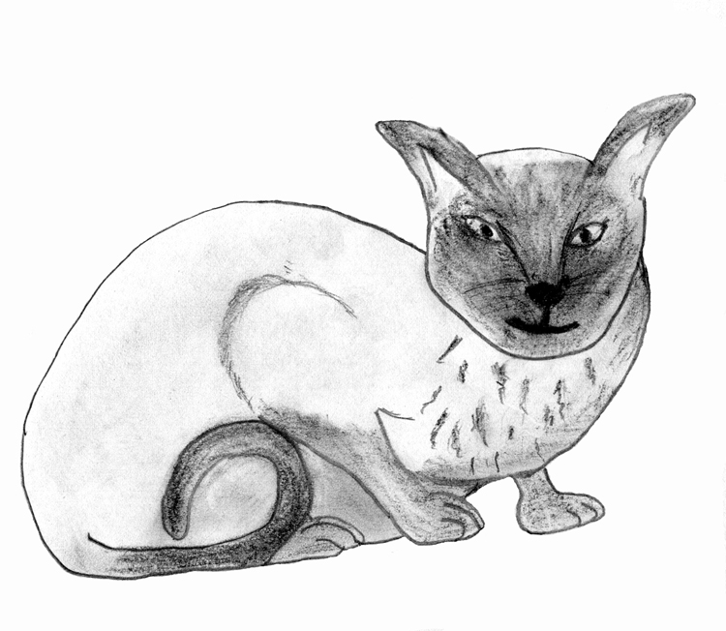

Chapter Ten

LITTLEJOHN

I am afraid I often say this one or that one was special, but I must say it of Littlejohn, or, as his proper title ‘Prince Littlejohn of Orange’ for he was the most special dog my dear husband, Jimmie, ever owned, or rather , ever owned him. He was so tiny, he fitted comfortably into a coffee mug, or his Dad’s coat pocket. He came to live in our house twenty-eight years ago, as a birthday present for Jimmie.
At that time, just before we retired and left Bournemouth to return ‘home’ to Cornwall, I had my little chihuahua, Paddy, and wanted to get one for Jimmie, so we each had a little ‘hot water bottle’ to keep our feet warm in the armchairs in our old age! So one evening, off I drove with my friend Dot, to a Chihuahua breeder to see if she had a suitable little bitch puppy. Yes, she had a lot of them, all ages, all colours, so many it was hard to choose, and a bit difficult, too, because one very tiny little white dog puppy kept coming to me and sitting on my foot – he was quite a nuisance! Unfortunately, at last I picked him up and he licked my face, so I put him down quickly and he ran a bit away, then backed towards me and sat on my foot again. I explained to Dot that I didn’t want a DOG, and she said it looked as if the dog wanted me, but somehow of all those lovely, bitch pups, I could not choose one! So I decided to leave it and discuss it with Jimmie! Off we drove, promising to return next day, and at the end of the road I turned round the car, paid my cheque, and took ‘Littlejohn’ home to a delighted Jimmie. They clicked at once, the tiny fellow crawled up under his new Dad’s cardigan, and then slept in it all night on the end of our bed. Littlejohn had come home – cardigan was much nicer than Mum’s foot. He and my Paddy were wonderful pals, and one memorable occasion, quite accidentally, they created five beautiful puppies, three like Mum and two wee white little girls just like their Dad. They never had another opportunity, and when Paddy died he was so upset and missed her so terribly we decided to get another one to keep him company, as their pups had all grown up and left home.
We heard of a lady in Newquay, who had two pups but alas! We were fooled again! Little gold Judy wanted me and little black Josie chose Jimmie! So, of course, we took both home with us. Littlejohn was adamant in his choice – he adored Judy but, only tolerated poor, shy, little Josie. They were so different, Judy full of beans, friendly, afraid of nothing or anybody, Josie always timid and shy, but dear little things, we loved them all. Littlejohn never had any ulterior designs on either of the girls. I think in his old age Judy exhausted him a bit. She had him right under her paws. She could pinch his food, commandeer his bed, boss him about, but he had not the slightest interest in Josie, though that didn’t worry her. She had us and was a lovable little creature. Alas, in his very old age, Littlejohn was widowed suddenly, when we lost our darling little Judy. She died quite unexpectedly. It was sad to see our little prince change so quickly. He fretted, refused to eat and despite his seeing her peacefully in her last sleep, to save him looking for her and trying somehow to get him at least to take some notice of Josie, grieving as well, he just pined and quietly died one night, leaving Josie to keep us company for another few years, in which she came out of her shell and spent happily devoted, especially to Jimmie.
Funny little animals, all different, but all so devoted to the humans who try to understand and love them. What a blessing they are to our lives.

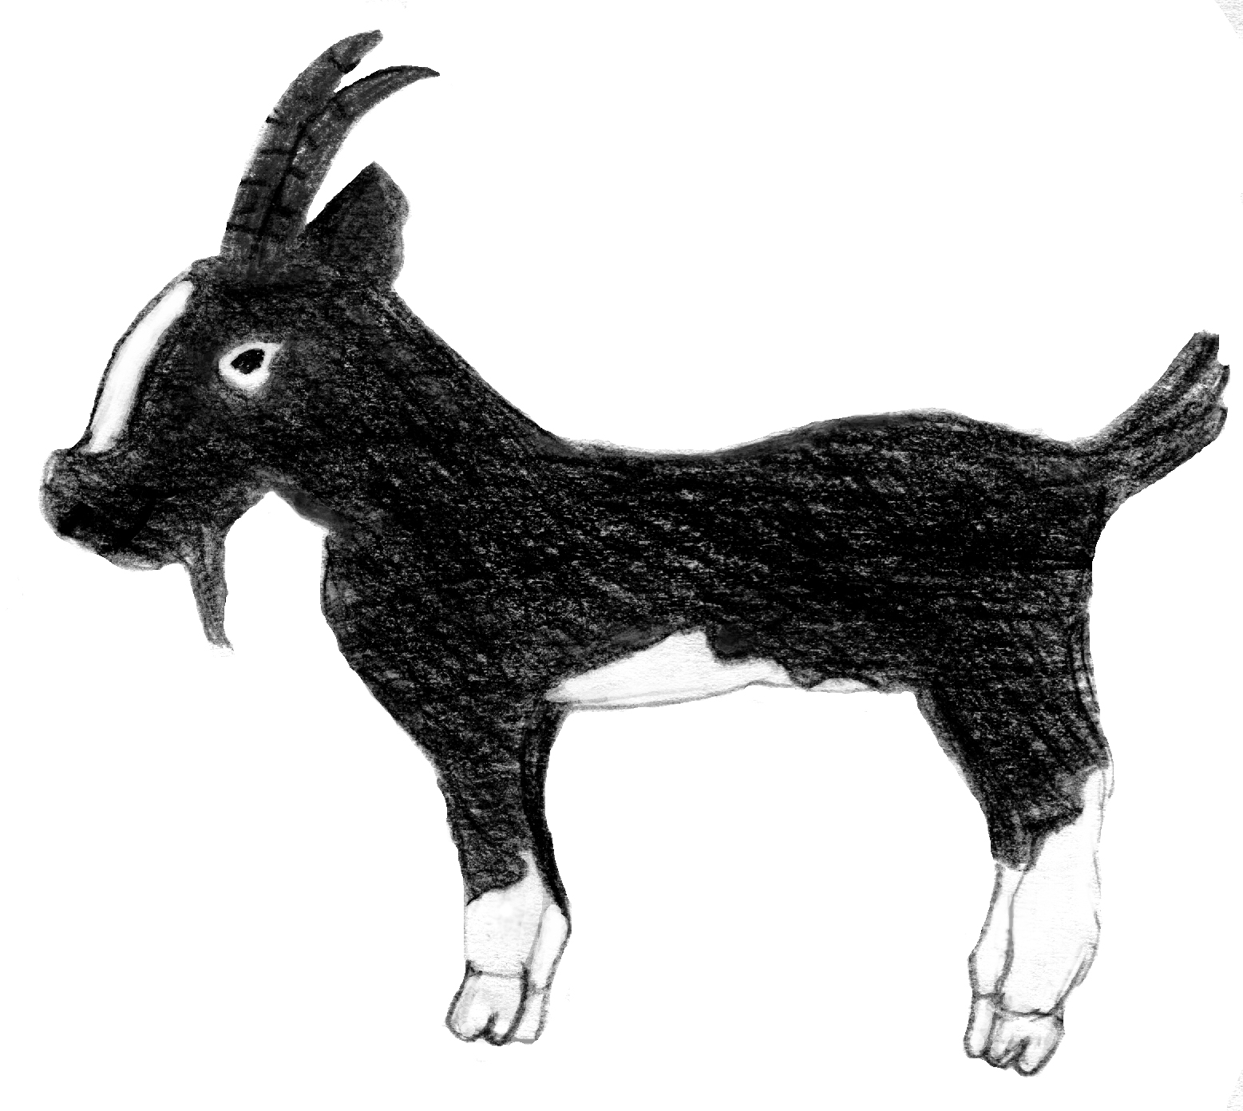

Chapter Eleven

THE GOAT THAT CRIED

Oh! I nearly forgot the goats, how could I be so stupid!
A few months after the War we left the Isle of Wight and all its adventures and went to live for a while in a village not far from Reading, where my husband moved to work. We and the two girls moved into a tiny accommodation, surrounded by a tremendous garden containing fruit trees, bushes, shrubs, masses of grassland, and even a little pond with a real kingfisher on guard – fantastic! So, of course, we soon acquired a dear little Saanen goat who quickly provided us with an even dearer littler white kid, who was born on Patricia’s 8th birthday and obviously, we named her Patsy. A little later, and I just cannot remember where she came from (rescue, I expect), a huge black nanny-goat with tremendous horns and a body nearly as big as a donkey, who we named Maudie for some reason, came and they all lived together happily with the dogs, cats and two pet ducklings named Dilly and Dally who followed us around like dogs.
Maudie was one of the gentlest creatures I ever knew, and allowed anyone or everyone to milk her and provide luscious milk for all and sundry, even a neighbour’s baby for a while in an emergency.
I got quite fond of ugly old Maudie, and she seemed to be fond of me, and always trotted to meet me if I went into the garden, but one day when she followed me down a rather muddy bit of bank she slipped and fell on to me, and the sides of a huge horn bashed into the bottom of my spine, and down I went too, with poor old Maudie on top of me! Being in pain and shock I stupidly cried, not like me at all, and I shall never forget the look on that old girls face as she also struggled to get up. She was so upset, moaning and licking my face, and I swear she was actually crying, not for herself, but because she had hurt me! For days she was round me whenever I went out, silly old thing, but I admit it HAD hurt! I could hardly sit on the bus to town for weeks.
Dear old Maudie, what a character she was, and how sad we all were when we moved into a proper house with a compact garden – oh! How we missed those fruit trees, especially the luscious Victoria plum.
A few weeks after we moved someone telephoned us with very sad news about Patsy, living now with the other two in a big field on farmland with an old donkey and some cows to share it. Apparently a bull terrier, which no one claimed, picked on her and nearly tore her to pieces before the farmer, hearing the commotion, picked up his ever handy gun and shot the dog and then a nearly dead little nanny goat, to put her out of her agony. How could a dog like that be somebody’s pet? Thank goodness Patsy’s former little mistress did not hear about it for a long time, and never knew what had really happened. They were the only goats who ever owned us, and I hope they were well cared for to the end of their lives. But I must just mention another unusual special pet, a little hen.
I bought her in a market in the war for half a crown, because she looked lonely in a small pen on her own, and I was afraid someone might pick her up and take her to be a tasty unrationed meal!
I took her home and she settled with my other two, but one day she got out of their enclosure and found her way indoors and laid a big brown egg on our settee (and after that effort insisted on doing the same whenever she felt so inclined). Luckily she quickly went out and appeared to be well house-trained. I named her Maria. Even in acute old age she never went into the pot, and when we moved she was in a dignified grave at the end of the garden, marked with her name. I wonder whether anyone ever exhumed that grave to find out who Maria was?
Usually when I take a service in our local Church, and quite often in other Spiritualist Churches, my brother Tony, who helps with animals in Spirit (yes! There are some there I am told), often brings them back to their former owners, not only domestic but sometimes so called wild ones to whom humans have become attached.
I remember, a few months ago, I saw a rather young elephant, standing by a very elderly lady, in the congregation and I heard Tony whisper “AYAH”, so, in a slightly humorous way, I told the lady that the little elephant seemed to know her. I must admit I was quite surprised, although Tony has never let me down, and she looked quite amazed. An elephant? In a Church? Whatever next! I told her she was only a baby elephant and her name was Ayah. At that the dear old soul burst into tears and explained that when she was a child, her family lived in India, but had to come home quite suddenly. The little girl had always loved animals and became very attached to an orphaned baby elephant, brought in to be reared, after the mother was slaughtered for her tusks. The old lady composed herself, and said “Oh! How wonderful! I was heartbroken when told we couldn’t bring her to England, I loved her so much. Yes - her name was AYAH!”

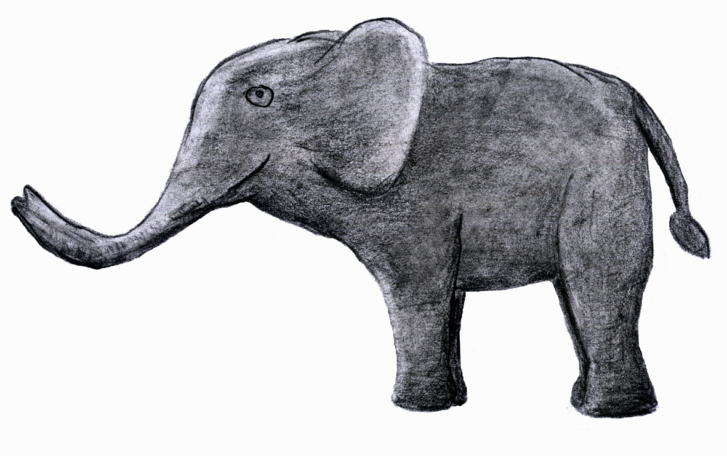

Chapter Twelve

LOST AND FOUND

Every week I buy the local paper mainly to read the ‘Hatches, Matches and Dispatches’, to try to keep in touch with the new babies, marriages and if any special friends have been ‘promoted’, and also, very important, any lost animals. I always cut out, date and keep this important ‘lost and found’ information and as a result have been blessed to have found such a number of dogs and cats. Not every wet, hungry, little creature has been cruelly abandoned; as we well know, many an inquisitive cat, climbing into a car or van, has been carried miles, even a dog at times; terribly frightened, or nearly scared to death by a firework, dozens of hazards.
Some years ago, we lived on a very busy main road into Bournemouth, and one morning I went out early to post a letter and to my horror saw a tiny white Chihuahua in the road, causing chaos, trying to cross over to my side. “Oh! You poor little beauty “I cried and the wee creature rushed up to me, and I thankfully grabbed her. A number of cars had stopped, thankfully with no damage to the precious vehicles, and two irate drivers wound down their windows and cursed at me, and one told me to keep my dog on a lead! I was so embarrassed and fled indoors, the tiny dog trembling in my arms. I decided to go house to house before ringing the police, but no one knew the dog at all, although seven houses down the road, at the vicarage, I was told in no uncertain terms not to bring any dogs near their home! So back I went indoors and gave it a drink of milk. She was a little beauty, and I told her so and she was so friendly and quickly I went to try the other side of the road. Still no luck but then I noticed a side gate of the next house was open just a little bit, so we went to the back door, and the old lady sitting at the kitchen table with a cuppa exclaimed “Oh Beauty! I thought you were in the bedroom!” What a happy reunion! For the first time ever, the milkman had not closed the side-gate properly and somehow little Beauty had slipped out. Her old mistress wept with relief and after that, I learnt later when I paid them a visit, the gate was never unlocked – the milk was left at the front door! I wonder who made me call her Beauty? - but she was.
Panda was, as I have said before, a different kettle of fish. For one thing he was a cat, a grand plump, friendly black and white fellow, who came to my back door one drizzly evening, and cried so loudly outside that I opened the door and in came a completely strange feline, who stood and stared at my little dog Paddy, who just fled out of the kitchen and hid her cowardly self elsewhere, and I, rather surprised, said “Who are you? Where did you come from?” and I am quite sure I was told “I am cold and wet, lost and starving”, a lot of lies, I was sure, but at least I would give a little sustenance, and he accepted the saucer of milk and a few tinned sardines, as if he was conferring an honour upon my household by doing so! He then settled down in Paddy’s basket and thoroughly washed himself all over.
Then I had a thought. In the local paper yesterday was a mention of a black and white cat, lost two weeks ago. Might as well give them a ring, but this cat did not look as if he had been lost for over two weeks. I rang the number, but the owner’s lived at least five miles away – impossible! They had been on holiday and a neighbour had looked after the cat, which must have gone looking for them, and they had come home today. But it was the neighbour’s phone number in the paper and they were desperately hoping to find the cat before the owners arrived home. I asked the name of the cat and repeated it after they told me – PANDA. As I said that the cat ran out of the kitchen to me and I said “I think I have your cat – call him on the phone”, which they did and Panda tried to get into the phone to them!
A shooting brake full of both families arrived about ten minutes later, and four adults and three children greeted his lordship, who had the lot of them under his thumb and they wanted to shower me with money and chocolate rewards, but my wonderful reward was to see the love showered and reciprocated by that artful lying old cat who must have found many kind new friends in the two weeks he had travelled over some of the busy roads his real family went over on their holiday. How did he know the direction?
There have been so many. Somehow there is a disorientated sort of block about a really lost animal, perhaps deaf or nearly blind and wandered from the smells of familiar territory. Perhaps St. Francis has special minions like my brother who told me he is permitted to work with animals in Spirit, and tries to get us to help him as well. I know he has enlisted my aid many times in finding, caring and healing, I have said sometimes, facetiously maybe, if St. Peter does not let me in at the first gate maybe St. Francis will let me squeeze into the back! I do honestly believe that at least in our case, my brother Tony in Spirit and I, still living on earth, both with an interest in all living creatures, have often been allowed to work together to help and ease just a few of God’s ‘other’ creations. I always do ask his help if I really need to, I do realise he is on his own journey of progression, on a higher vibration and not just at my beck and call, but I also feel he has chosen to help when and if he may and for that I am grateful.
Nowadays the wonder of micro-chipping has helped many lost or strayed pets to be reunited with anxious owners and even my own daughter had a dearly loved cat, injured in an accident up the road, returned to her by a stranger who picked him up, rushed him to a vet, even offering to pay for his treatment if he was not micro-chipped. He was fortunately, and he fully recovered, and here was a real animal lover. I am pretty sure St. Francis will welcome her one day!
Joking aside, if ever I find an animal obviously lost or injured, or even dead, I take it to my vet to check for micro-chipping, so someone somewhere might not worry and wonder what happened to it. There are folk who can worry for years – we cannot help it! Have they been vivisected? Have their skins been used for a pair of gloves or children’s toys? Only if they are dead can we stop worrying. If you don’t believe me, and have never come across Sylvia Barbanell’s wonderful book ‘WHEN YOUR ANIMAL DIES’, I advise you to beg borrow or BUY a copy (if you have to steal one, please give it back after you have read it!) mine is somewhere on a long loan – I hope it is doing some good, but I can’t remember where it went.

MESSAGE FROM MAC

You are a special human friend,
Faithful and loving too,
We’re sorry my life had to end,
But I’m still close to you.

Please talk to me – I love the sound
When you speak tenderly
And than you that you always found
The time to play with me.

The walks, the cuddles and the food
You gave me every day.
The way you made my life so good
In every kind of way.

I’m glad we met, what fun we shared
This is no time for tears
As I remember how you cared,
And all our happy years.

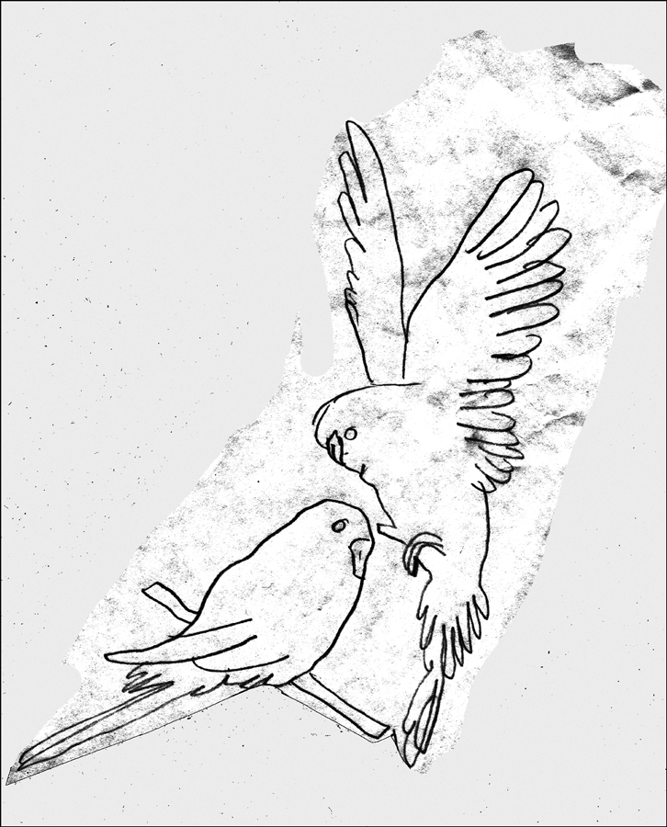

Chapter Thirteen

WINGS

Among my many companions I have had a number of budgerigars and what really delightful people they can be, even if they do love to sling feathers and seed shucks all over the place! I had one bright yellow fellow called Koko and a number of my knowledgeable friends told me he must have been a canary, but if so he was the most talkative canary that ever lived I guess. I bought him, a wee baby, from an aviary filled with budgies of every hue, so I told them that maybe a canary got in one night and his mother went astray, but I never heard him sing! I also had a sweet little white female called snowdrop, she was so tame and even tried to talk a bit, bless her.
The last one I had was a little blue boy called Bonnie and he had been around a bit in his life. I acquired him on the death of an old friend, who had had him for seven years, and had got him from her sister, who, she said, had had him “for ages”. He lived with me for over six years. He was delightful and had been taught to talk a lot, could even recite a few muddled-up nursery rhymes, causing amusement and he was so happy, loved my little dog Paddy, and would even curl up with her in an armchair, or travel around on her head, which worried Paddy a bit. Fortunately we had no cat then – I would never have trusted a cat near him. He welcomed any visitors, but nearly broke my heart one Christmas morning when, as I uncovered his cage and opened the door (so we could breakfast together), he politely informed me that I was a “pretty boy” then dropped dead off his perch, such a shock! Dear little fellow really upset our Christmas Day – it was so unexpected! But he must have been quite old, bless him, and at least went quickly, and had a very special Christmas Day funeral.

* * * * *

SWEETIE BOY

My older sister Trixie, many years ago, had a very tame canary she called Sweetie Boy, and the little bird really loved her and always greeted her with song when she came home from work. Sadly Trixie died aged only twenty- two, just after Christmas 1929, from peritonitis following an appendicitis operation, and little Sweetie Boy, despite the company and attention of our family, quietly pined for his specially loved human, and died about a week afterwards. He was, I am told surreptitiously slipped into Trixie’s coffin as it laid in the family sitting room.
Many years afterwards my daughter, Patricia, was invited to a materialisation séance in a medium’s home and was surprised when one of those spirits who appeared introduced herself as “Auntie Trixie” and said “Tell your Mummy I have Sweetie Boy” and in her hand was this little golden canary, which flew round the room, then back to Trixie. What a wonderfully evidential experience for her young niece who had known about Trixie but never even heard of ‘Sweetie boy’.

* * * * *

Writing about birds, what a wonderful creation they are, and how cruelly man-kind so often treats them. Many years ago my dear husband and I had a memorable once and only holiday in Italy, and we stood and gazed at the statue of our beloved St. Francis of Assisi standing with some of his precious birds around him and held gently in his hands, but not a living bird then to be seen- only hundreds of the mostly tiny corpses on skewers, for sale in the shops around the town. I shall always remember them!
Even little Sweetie Boy was not always confined to live in a cage for safety, he was allowed to fly around the house every day if he wanted.
One creature who somehow never took over my home was a parrot. I have met many in my life, and have always been fascinated by them. I once had a beautiful cockatiel, who needed a home, and was thrust upon in a tremendous cage, but somehow we did not really bond, and he left for an excellent, loving home. but my younger daughter, Patricia, was once owned by a wonderful Amazon Grey parrot called Toby, and their adoration was mutual. His cage door, I am sure, was hardly ever closed.One Christmas Day a big party was arranged for the evening, over thirty family and friends, so Toby was taken next door to join his brother, who lived there, just in case the noise stressed him. Alas, something did for early on Boxing Day, when Tricia went to bring him home, he suddenly died – another awful Christmas tragedy!

Chapter Fourteen

ODDS AND BODS?

HAVE I MENTIONED Ernest? How could I ever have forgotten him? I found him in a pet shop in Bournemouth years ago, when it was possible to buy a tortoise for a shilling or two. The owner had a consignment of Tortoise of all ages, and in one corner was a really tiny one and I looked at him, and his little head popped out and looked at me, and goodness knows how traumatic his life had become, so I bought him and took home my first and only tortoise, and a small book on how to treat and feed him (I felt that was important). I asked the shop owner what his name was, and he said, regarding me suspiciously, “I haven’t a clue! but MY name is Ernest”.
So Ernest is what I named my tortoise and he lived with us for about two years, seemed quite happy, hibernated in a box of hay indoors, but one day came calamity. I found him in the garden, upside down, obviously dead. I had been told that if one did fall over on its back it died, but just to be safe I snuggled him into his hay-box, in case he felt cold and had decided to hibernate in the middle of summer, but to no avail. I felt terribly guilty that he had not lived to the proverbial old age of a usual tortoise, and imagined him struggling to turn over. Oh! Ernest, PLEASE forgive me! Not finding you quicker!
- - - -

This is the solemn requiem
I broken-hearted tell
Of a little chap called Ernest
Who lived in a tortoise shell.

Alas! One day he toppled
On to his back he fell,
And that was the end of Ernest
Who died in a tortoise shell.

* * * * *

I suppose I should mention the alcoholic gold-fish which I won at a fair when I was about eight years old and carried home in a jam jar, and my Father actually allowed me to keep him. Mum bought me a decent bowl for him, and for a few weeks he kept his end up and seemed quite contented with his extremely monotonous life. Alas, one morning I found him floating on top of the water, looking very dead. Now, I had heard once that if anyone fainted, a drop of brandy or whiskey helped revive them, so I surreptitiously took a small drop or two out of Father’s whiskey bottle and dropped it on to the fish, who, a few minutes later, suddenly popped up and like Lazarus, came to life. What a miracle!
I honestly cannot remember how many times this happened, and luckily Father never once caught me raiding the bottle, but one day the silly fish decided to ‘die’ when I had gone to a birthday party, and when I came home the bowl was empty and the poor fish had vanished. Father had found him this time – poor, alcoholic little goldfish! How ironic that the human who unknowingly was instrumental in reviving him so many times, was the one who tipped him away and, I am pretty sure, pulled the chain to make sure he really left us!
Every time I mention another little companion I seem to remember one more! How could I have overlooked (certainly not forgotten) perhaps the most unusual of them all? I could only have been about ten years old when, on the first day of the wonderful summer holidays from boarding school, when I went to spend six glorious weeks at home with my Mum and two brothers, I found this little person sitting on a stone in the sunshine in Pelham Wood near Ventnor in the Isle of Wight. No, he was not a pixie, but a little green lizard who did not seem a bit afraid of me. We just looked at each other, he sort of smiled, and I picked him up and took him home, and surprisingly, he was my constant companion for about five weeks. Everyone helped me make sure Father never discovered I had him – he might have thought he was a newly born alligator!
For some reason I named him Bertie, and he was a friendly little chap. He loved to run up the curtains sometimes, and one day I missed him and my brothers and I searched everywhere but not a sign, and then, at dinnertime, with our Father at the head of the table, I noticed Bertie sitting on the curtain rail, behind Father, gazing down at all of us and I was terrified he might come running down for a tit-bit, as he seemed interested in a snack of any sort, even if he declined to eat it. Of course, he had proper food considered fit for lizard consumption, and fortunately that day could not have been hungry, for he remained just where he was until Father left the table, and then Bertie came running down and up my legs!
He spent most of his days sitting on my shoulder and I spent a lot of time cycling around with him for company, but alas, one day he slipped off as we cycled along the muddy lane by Pelham Wood and, despite frantic hunting and calling for days by my brothers and myself, we never saw him again. I suppose, really, I could not have taken him back to school with me, and consoled myself that perhaps he had found his family back in the woods, or even started one of his own, but I had a lovely summer with him that year.
When I returned to school they had all been given, by one of the parents, a large glass case full of stick insects to interest the pupils, and I was allotted the doubtful honour of being their carer, as I was fond of animals. The day-pupils were kind enough to keep them supplied with the greenery required for their food, and I can honestly say that they were, I think, the only living creatures with which I could not bond at all. I am terrified of spiders, and I certainly did not like to think of these queer creatures crawling around my hands and shoulders, but for all that I was a conscientious carer and made sure they were kept fed and even managed to throw the greenery into their house!
Someone told me once that the only ‘pet’ I had never entertained, besides a spider, was a FLEA! That reminds me of a special one I treated rather badly I fear, but in whose memory my little dog Bobbie and I composed a very special rhyme. He and I one day visited a posh house which seemed full of scratching cats and two very itchy little poms’, and when we got home Bobbie also started scratching feverishly – he had obviously picked up a ‘lodger’! I managed to find it after searching, and it appeared to be a lone one, and then my little dog and I sat together and wrote our mutual masterpiece
- - - - - - -

THE ITCHY DOG’S LAMENT

Long, long ago I’ve heard folks say
God felt a little bored one day
So made a world that He could play
With at His ease.

He shaped the mountains and the plains,
Created sunshine, snow and rains
Tornados, floods and hurricanes
And mighty seas.

Then as He viewed His world so grand
Bade Mother Nature take a hand
And work as Second in Command
On flowers and trees.

And then He had another plan;
He said “I’ll make some things called Man,
And if they’re any good they can
Do as they please.
They’ll rule My world and I’ll agree
(If we can work in harmony)
To help them, if they just ask Me
Down on their knees.

Then God, to keep man company,
All creatures great and small made He
To live together happily
In love and peace.

Huge dinosaurs, then birds and bats,
Pigs, horses, whales and pussycats;
Dogs, butterflies, giraffes and rats
And honey bees.

God was so proud the world He planned
And all His creatures looked so grand –
But I shall NEVER understand
Why He made FLEAS!

* * * * *

Now I have no dog, no cat, no budgie, no goat no etc., etc., no nothing – Oh! Yes, I have Benjie! How could I live without somebody around?
My children and I have had a number of guinea pigs in the past, and Frankie still has a small brood, but my last was a tiny golden boy I called Benjamin. Benjie for short, and he was like a little dog. He lived indoors, and adored dandelion stalks. I wrote a special little poem for him after he died – I missed him a lot.

DANDY STALKS.

He wasn’t really very big

My little golden guinea pig
But we were friends, he always came
When I called ‘Benji’ (that’s his name).
I used to carry him on walks
And feed him lots of juicy stalks
Of dandelions – spurned flowers and leaves!
It must sound stupid, someone grieves
A fluffy rodent, fat and small,
Of no significance at all!
But Benji, can you ever know
How anyone could miss you so,
And bury you so tenderly
Beneath an old laburnum tree,
Where ev’ry summer gold buds wave
Over your tiny lonely grave,
And prays that somebody, somewhere
Has picked you up, to gently care
For one wee creature, who loves walks
In fields of juicy ‘dandy’ stalks.

When my Little Opal died, I vowed once more NEVER to have another dog, but my practical elder daughter decided I MUST have something to love and look after, or heaven knows what or who I might bring into my small flat. So out of the blue, a few weeks ago along came Benjie, except he likes dandy stalks and cuddles.

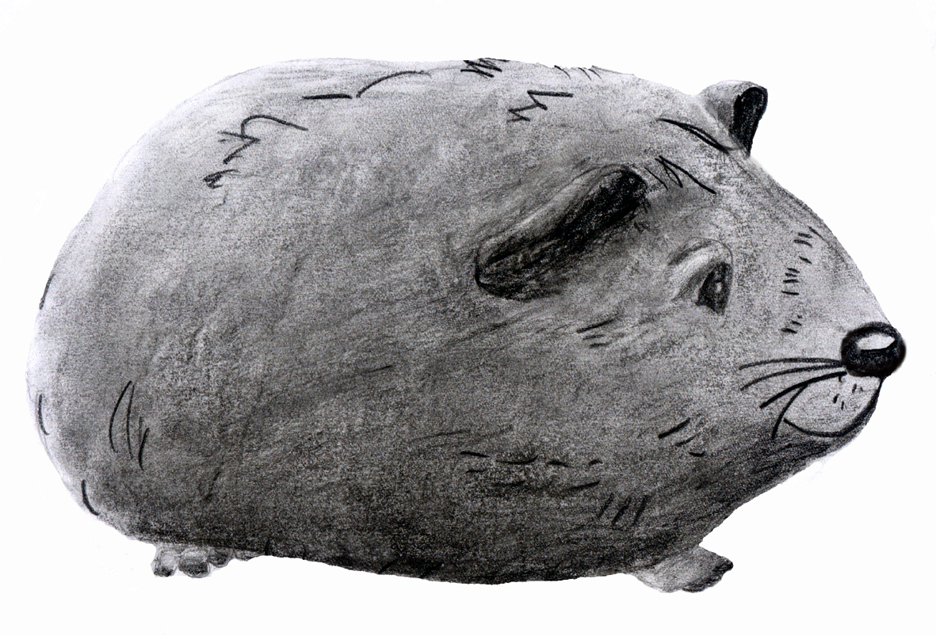

When Frankie bought him home, scared, thin and dejected after being taken into an animal sanctuary, I said, “I don’t want that!” Twice the size of Benji one, muddy-brown colour, but neverless he was left behind, in the lovely plastic ‘palace’ she had bought, together with a huge bag of special ‘dusted, sweet carrots’ etc and a large packet of guinea pig food, and I was told “He’ll grow on you Mum!” excepting those stick instincts they all seemed to have grown on me!
Now Sir Benjamin lives like a lord, is regaled with any sort of fruit and vegetable that his willing slaves deliver to his domain. He is completely house trained, and will carry on long conversations with me, (sometimes even with my brother on the telephone or any visitor who drops in to see US, as most of them are far more interested in Benjie than in me). He never argues with anything I say, for what better could any animal lover ask?

Before I finish I must mention a little message I had ‘from Opal’ which was given to me by a special medium at our church, who told me she was shown a piece of blank paper, looked like a letter, and in one corner was a little paw mark.
Clever little dog – she has already learnt to write! I always had to draw her paw signature on letters and cards we used to write to our friends, now obviously she can sign all her correspondence herself.
I always thought she was a very special little dog!

They frolic through our homes and heart,
We foolish pet –owned men

Until the’re an integral part of
Of very life, and then
There comes the day that they must go,
Their too short life is done.
Do we rejoice in freedom? NO!
We find another one!
F.L.N

‘THE LESSER KINGDOM’- - - I WONDER?

ADDENDUM

So my book is ended, and now my precious little OPAL lies, tucked in her special blanket a dear friend made for her, lying under the pear tree in Frankie’s garden next to another very old pal, Jade, the dear old Lurcher – two jewels together.
I wrote this for OPAL but I dedicate it for every human pet carer who still misses their very special companions
I wonder how many may sleep on our beds tonight?

Don’t forget to say ‘GOODNIGHT’ to them.

